Webpage:

Overview:

Social networking websites offer a fantastic platform for family members to stay in touch with one another. More contacts and communication with individuals throughout the world are facilitated by it. COOKIES was created to improve the effectiveness of interpersonal interactions and communication. Only HTML and CSS were used to design and create the prototype website. The home page, notification page, status page, follow request page, direct message page, and profile page are just a few of the several pages that make up this website.

HOMEPAGE:

This is COOKIES's home page. Friend stories, feed, a search box, page navigation, and a comment area are all included here. You may also leave comments on a friend's photo.

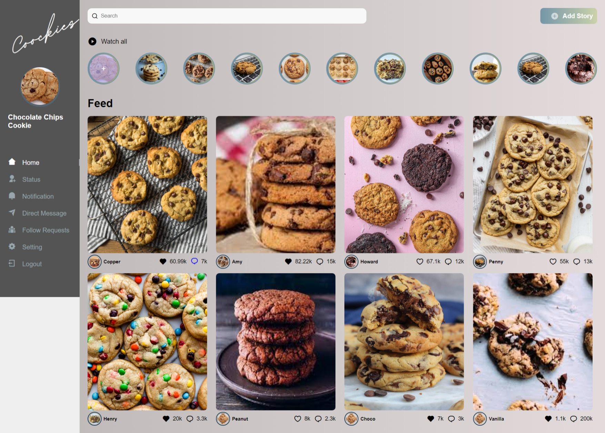

Comment:

This is the COOKIES’s comments section. For this comment part, we've utilized the popout feature. 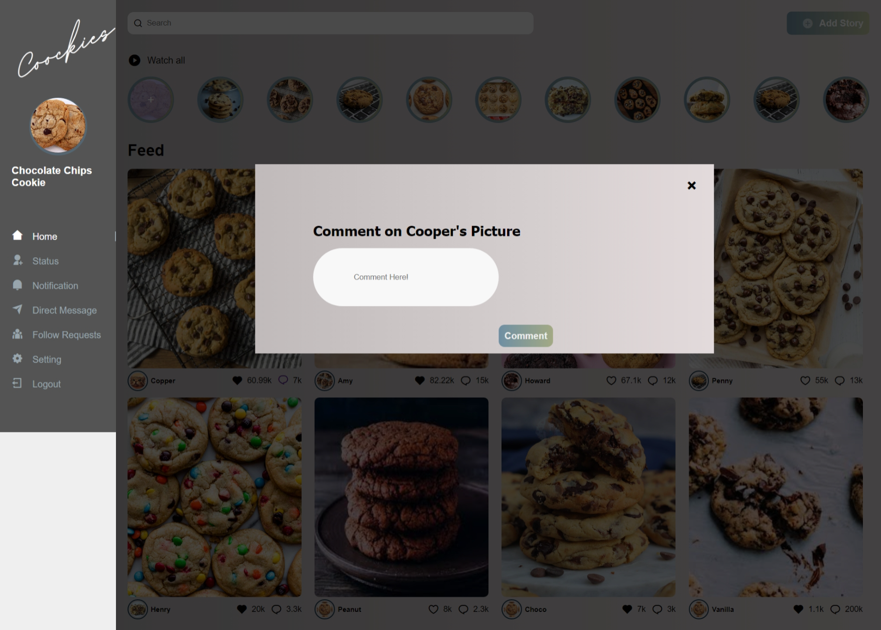

Profile page:

This is cookies's profile page. The follower and following parts are included above. You can change your profile by going to Edit Your Profile. Additionally, we have included the user's highlight narrative. 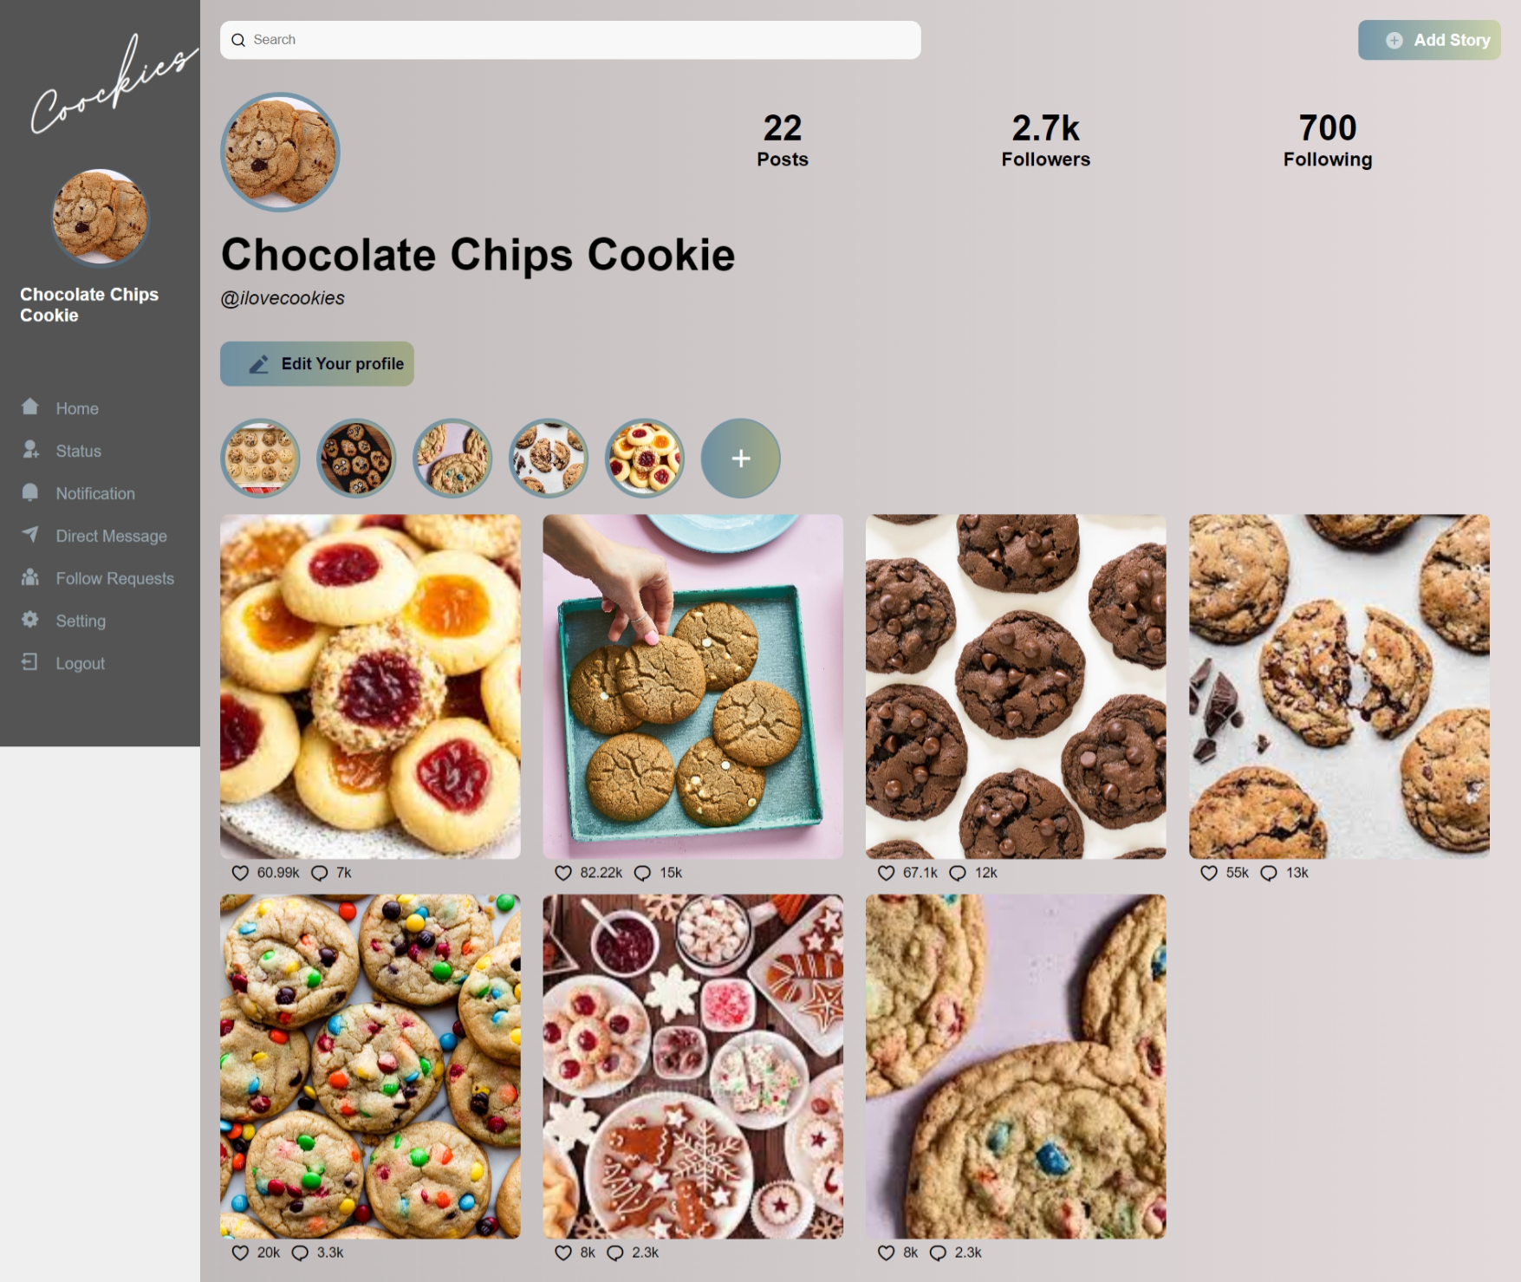

Status:

This is the cookies status page. You may post articles, stories, pictures, and videos here.

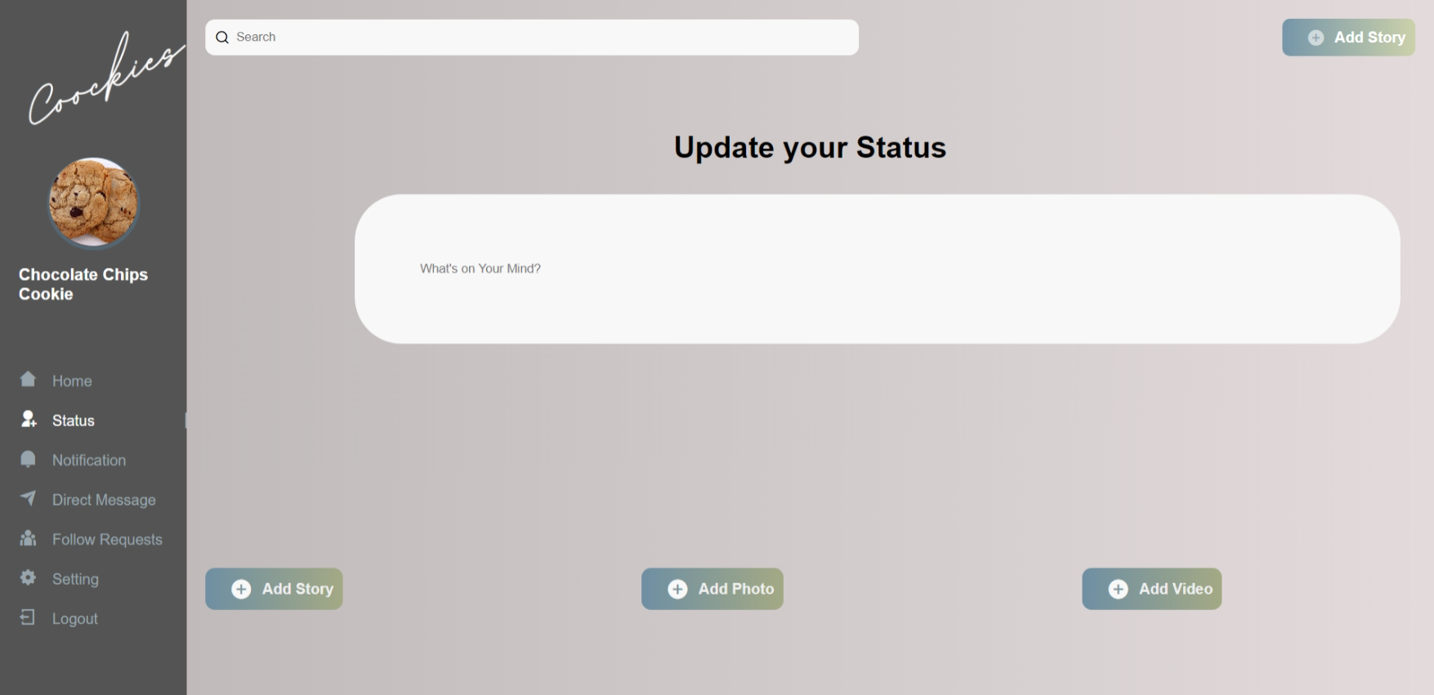

Notification:

You receive notifications following friends' activities on this page. 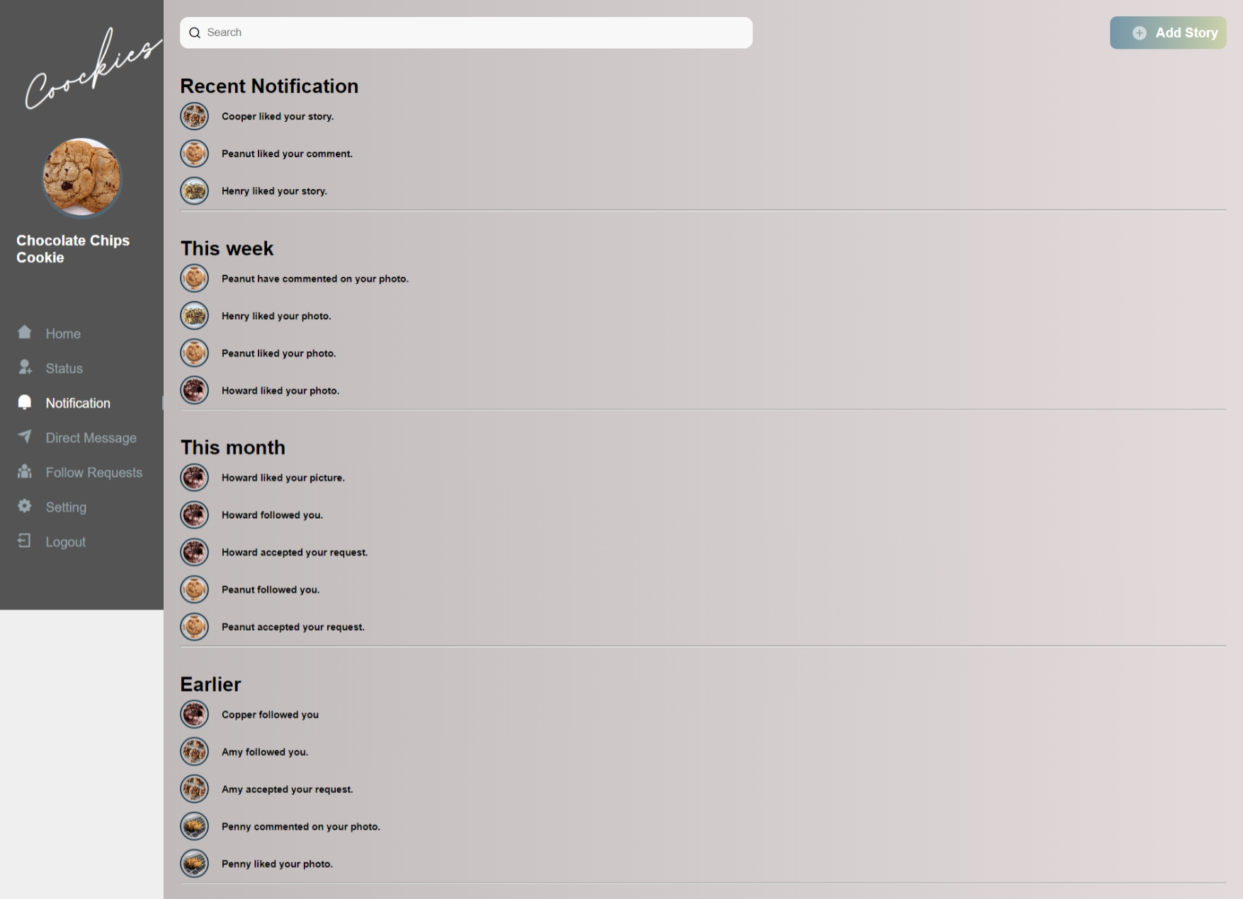

Direct Message

This is the page where you may send private messages to your pals. 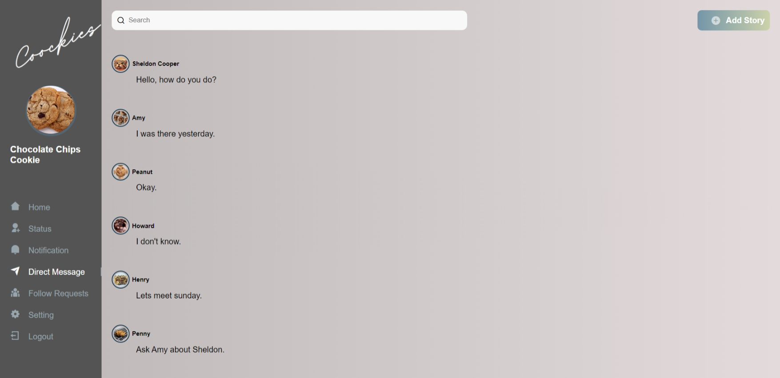

Follow Request.

Here is the page for follow requests, where individuals who know you may submit them as well as ideas for others you might know. 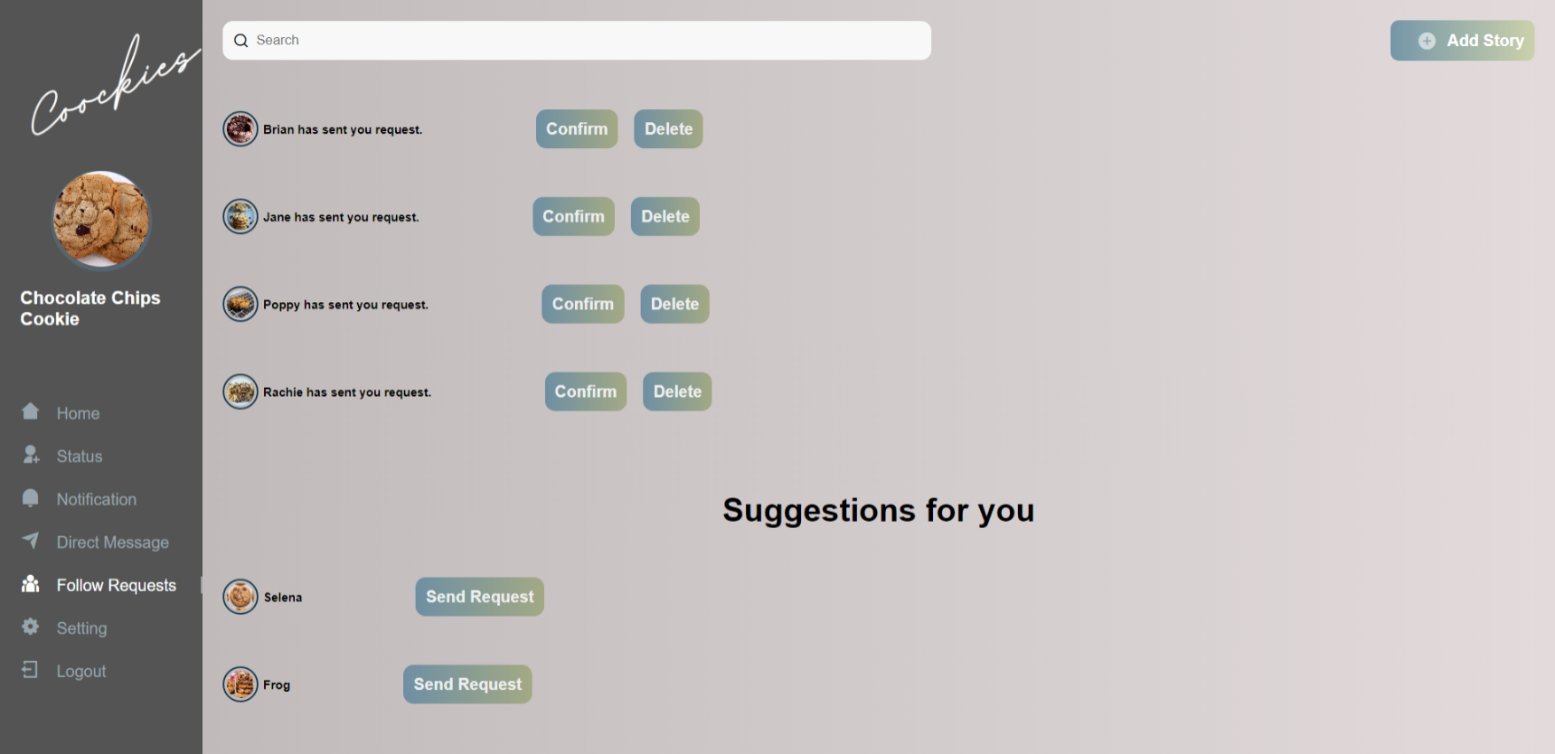

Database:

The website's ER diagram is shown below. User can update status and send/receive direct messages. User may give and accept follow requests from their profile page. User can like and comment on other users' pictures.